National School of Business Management
LAB Sheet 06
Lab 06 routing with multilayer switchers
Set up the following scenario on Packet tracer/physical
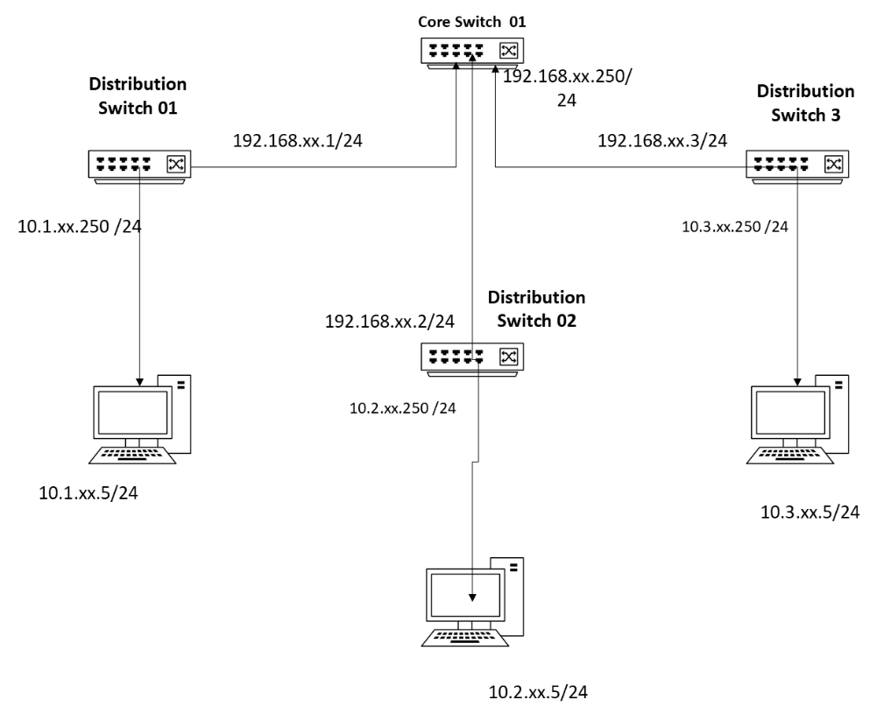
Note:- please reset the routers before you start
Step1. Identify the two different ports in the switchers
- Identify the ethernet ports you are going to use for connecting the PC and the Switch /s.
Step2 Assign IP
- Assign an Interface IP to the relevant ports/logical interfaces and Ethernet card of the computers
Ip interface must be in the following format on IPv4
10.1.X.250 / where the group number in single digit eg group 3 will configure it as 10.1.3.250
Step3 Testing basic connectivity
- Use the basic ICMP command

Step 4 Adding static routes
- The routers need to be configured to handle manual statis and must be tested if it

You may use the following commands to carry out the task

No | Disruption | command
01 | Switch to configuration mode – configuration terminal | Config t
02 | Switch to enable mode of a switch /router | Enable
03 | To go to VLAN configurations | vlan
04 | Change name Name | name
05 | To Access Interface commands | interface
06 | Assign the port to a VLAN. Valid VLAN IDs are 1 to 4094. | switchport access vlan
07 | Define the VLAN membership mode for the port (Layer 2 access port). | switchport mode access
08 | Define the VLAN membership mode for the port (Layer 2 trunk port). | switchport mode trunk
09 | IP address for the interface | Ip Address x.x.x.x y.y.y.y

